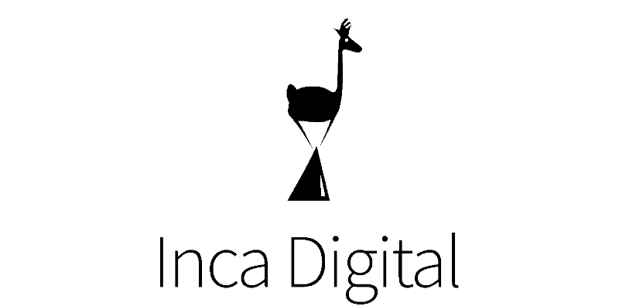**Remittances KYC Report**

Inca Digital, Spring 2021 Challenge

Christopher Denq, 12/14/21

# Table of Contents

Table of Contents 1

Foreword to Reader 2

Report Abstract 2

Report 2

Introduction 2

Two Major Remittance Systems 3

The Hawala System 3

Emergence of Regulated Remittance Providers 4

Top Providers 6

Defining Criteria for “Top” 6

Western Union Co. 8

Moneygram 9

Binance 10

OkCoin 11

CoinMama 12

Comparison 13

Conclusion 13

Report Considerations 14

Report Shortcomings 14

Project Statement Difficulties 14

Data Deficiencies and Researcher Bias 14

Confounding Variables 14

Possible Future Research 15

Supplementary 16

Research Process 16

Research Process: Visualizations 17

Report Bibliography 20

Supplementary Bibliography 22

# Foreword to Reader

|  |
| --- |
| Thank you for providing the catalyst to learn about remittance providers, especially those outside of the US; this ultimately was quite fun! The more research I did, the more questions I ended up with (a key feature of any project worth tackling, in my opinion).  Considering the nature of this topic and how little I knew of remittances to begin with, I approached this with a desire to holistically understand KYC requirements: a process that involved researching background historical, financial, and socio-political events surrounding my chosen region. More details on my research process, as well as any supplementary research done in service of curiosity, are appended at the end of this report. Thank you for your consideration!  - Chris |

# Report Abstract

With the recent decade seeing major economic upheavals, increasing acceptance of/literacy in alternative currencies, and rapidly developing fintech tools, crypto-remittances demand the attentive study of any contemporary analyst. This report first acknowledges a direct, major obstacle to the development of crypto-remittance providers in Afghanistan: the informal, peer-to-peer money transfer **hawala system**. It then compares the KYC requirements of the top two traditional remittance providers (who offer crypto options) and the top three crypto-remittance providers in order to get a holistic understanding of the relevant remittance landscape.

Traditional remittance providers like **Western Union Co.** and **Moneygram** have the least stringent KYC requirements when compared to their crypto-counterparts **Binance**, **OkCoin**, and **CoinMama**. Additionally, their KYC requirements are much less documented, with their various account perks not readily available. Within the crypto-providers, CoinMama has the highest required number of verification sources (9) for the highest level of non-enterprise accounts, while OkCoin has the least. Binance offers the greatest dollar amount of crypto transactions per number of requirements, as well as the greatest absolute dollar amount (daily limit of about 4.8 million). These crypto providers are overall quite similar in the level of security required for their lowest level of verification (the “basic” account) but have drastically different levels of verification at the highest levels. All three crypto-providers offer an enterprise-level account that unlocks the limit on exchanges but require specific contact and custom verification.

# Report

## Introduction

With the recent decade seeing major economic upheavals, increasing literacy in alternative currencies, and rapidly developing fintech tools, crypto-remittances demand the attentive study of any contemporary analyst1, 2. For many, especially those living in vulnerable or developing countries, crypto-remittances serve as mandatory lifelines3, potentially offering resiliency in value, ease of economic access, and higher security than traditional or local currencies. As such, this report will focus on the top crypto-remittance providers in Afghanistan–the country with the largest rate of national poverty on the challenge list as of 2021–in effort to understand how KYC remittance requirements might be adapted.

## Two Major Remittance Systems

There are two competing remittance systems within Afghanistan: a well-established and cemented informal system known as the hawala system and a more recent, formal system composed of traditional and crypto-remittance providers.

### The Hawala System

Overall, growth in Afghanistan’s banking sector has been slow–even resisted. Less than 20% of Afghans own bank accounts in 2017 according to Global Findex4, with even fewer using it regularly. Difficulty in establishing more regulated providers go as far back as 2014, with a U.S. Department of State report stating5:

|  |
| --- |
| “Official corruption and weaknesses in the banking sector incentivize the use of informal mechanisms and exacerbate the difficulty of developing a transparent formal financial sector in Afghanistan.” |

This resistance was exacerbated in late 2021, as well, when Afghanistan underwent a financial freeze following the Taliban re-administration of the country. The International Monetary Fund (IMF)6 withdrew financing, and major remittance players like Western Union Co (WU.N)7 and Moneygram (MGI.O)7 ceased operations as early as August of 2021. While these large providers would resume their services by October, this sudden gap in structured financing led to a swift loss of confidence in western providers and relapse back into the hawala system. Informal, unlicensed, and unregulated, this structure for currency exchange has been a staple in Afghanistan for years, continuing to offer a consistent method of money transfers for a country that desperately needs it.

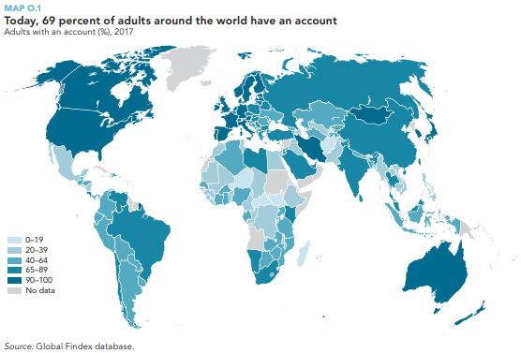

Less than 20% of Afghans own bank accounts in 2017, according to Global Findex.

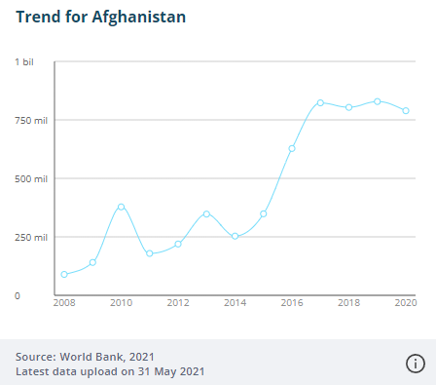

Remittances play an increasingly vital role in the Afghan economy.8

The minor dip in 2020 is likely due to pandemic conditions.

### Emergence of Regulated Remittance Providers

However, despite the dominance of the informal money transfer sector, there are a number of remittance providers that offer competitive alternatives. Based on a published study by Samuel Hall9, 10, disadvantages of the hawala system…

* lack of regulation and record keeping,
* operating rates unfixed/unadhered to foregin exchange rates,
* unstandardized loan rates,
* trust-based system with no collateral,
* over-emphasis on “hard” money / no crypto-option,
* and (more recently) pandemic conditions stricting in-person money transfers…

are enough to push some members to more formal remittance providers. Additionally, there are government and co-government initiatives (under the NFIS Coordination Council) that encourage swapping to regulation-standard services, like The World Bank and International Monetary Fund (IMF) development programs and the recent private fintech company spike10. According to the Chainalysis Index, Afghanistan shows a promising, albeit slowly, developing crypto adoption rate11 at a score of 0.13.

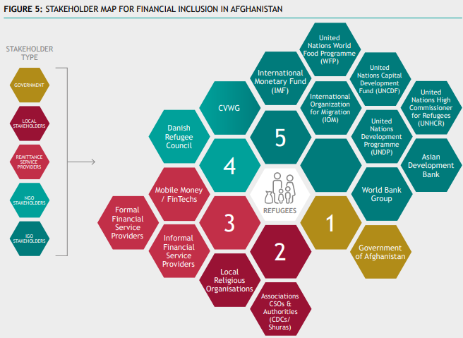

Stakeholder map for the NFIS Coordination Council, showcasing explicit interest in supporting and developing formal financial service providers and mobile money startups (space for crypto-remittances)10.

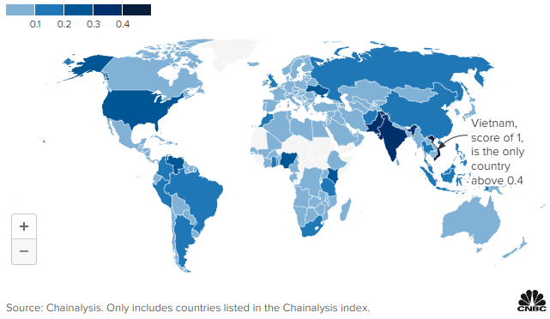

Global Crypto Adoption Index, a score from 0-1 that measures total crypto activity,

trading activity of non-professionals, and peer-to-peer exchange trade volume

(weighted by purchasing power parity per capita.)

Having briefly acknowledged the dynamic interplay between the informal and formal sectors for currency transfers, it seems like analysis of the Afghan remittance landscape would be incomplete without comparing a wider pool. As such, KYC requirements for the top 2 traditional remittance providers (that have crypto options) and the top 3 “pure” crypto-remittance providers will be compared.

## Top Providers

### Defining Criteria for “Top”

The table below sorts a limited list of traditional remittance providers that explicitly offer services to Afghanistan. The table is sorted in descending order by either a reported or estimated 2020 revenue in pounds; in the case where a 2020 revenue report was not given, the most recent year was taken instead. The remittance providers were then marked with whether they provided cryptocurrencies as a transfer option and whether use of blockchain was explicitly mentioned on any company page.

|  |  |  |  |
| --- | --- | --- | --- |
| Traditional Remittance Providers with Crypto Options | | | |
| Provider Name (HQ Country) | 2020 Revenue (£) | Crypto Option? | Explicit blockchain use? |
| Xe Money Transfer (CA) | 7.55B | Yes | No |
| Western Union (US) | 4.22B | Yes | Yes |
| Moneygram (US) | 679M | Yes | Yes |
| Wise (UK) | 302M | Yes | Yes |
| Revolut (UK) | 222M | Yes | Yes |
| WorldRemit (UK) | 210M | Yes | No |
| N26 (DE) | 130M | Yes | Yes |
| Small World (UK) | 107M | Yes | Yes |
| Monese (UK) | 62.8M | Yes | Yes |

Because this report was unable to find any data on “on-the-ground” popularity of traditional remittance providers in Afghanistan, it will refer to the two largest providers via revenue gain: Western Union and Moneygram. These two remittance providers were also covered in Reuter articles12a 12b following the Taliban administration change, verifying that these two providers had at least some remittance presence in Afghanistan.

Having established the top two traditional providers, this report will now turn to their crypto counterparts. The table below sorts a limited list of crypto-remittance providers that explicitly offer services to Afghanistan. The table is sorted in descending order by either a reported or estimated 2020 amount raised in USD dollars.

|  |  |  |  |
| --- | --- | --- | --- |
| “Pure” Crypto-Remittance Providers | | | |
| Provider Name (HQ Country) | Total Funding ($) | Digital Currency | Blockchain? |
| Ripple (US) | 294M | Ripple (XRP) | Yes; uses Ripple Protocol Consensus Algorithm (RPCA) |
| Flutterwave (US) | 234M | N/A | Yes |
| Bithumb (KR) | 200M | N/A | Yes |
| BitPay (US) | 74M | N/A | Yes |
| Binance | 35M | Binance Coin | Yes |
| OkCoin | 10M | N/A | Yes |
| Stellar (US) | 3M | Lumens (XLM) | Forked off of Ripple; uses Stellar Blockchain |
| Coinmama | 2.4M | N/A | Yes |

Unlike the case with traditional providers, information on the popularity of crypto-provider use in Afghanistan was found13. Despite being on the lower end of total funding, the crypto exchange platforms Binance, OkCoin, and Coinmama have been selected for a more accurate study of Afghanistan’s remittance KYC landscape. Thus, a total of five providers will be compared for a more holistic view on Afghan KYC requirements.

### 

### Western Union Co.

The KYC requirements for Western Union are overall the same, with slight differences in the valid photo IDs depending on the region14a, 14b, 14c.

|  |  |
| --- | --- |
| Transfer Range (every 3 day period) | KYC Requirement |
| 0 - 999.99 of local currency | None |
| 1000 - 5000 of local currency | Photo ID Credit/Debit Card (if requested) |

The required visible details of the photo identification are as follows:

* Photo ID
  + Picture
  + Signature
  + Birthdate
  + Expiration date
* Credit/Debit card
  + Full name
  + First six and last four digits of card number
  + Bank name and logo

Valid forms of identification are

* Passport (except spain-issued)
* National ID
* Resident Permit
* Work Permit
* Emergency travel document (in-person only)
* Ship’s passport (in-person only)

Confirmation can be completed via five methods:

* Email
* Mail
* Mobile app
* Website
* In-person at agent location

### 

### Moneygram

The KYC requirements for Moneygram are similar to Western Union, though with two notable exceptions15a, 15b: 1) uses reference numbers (or a tracking number that the sender receives as confirmation of the transaction) and 2) allows a greater transfer of money at the cost of a much more in depth background check.

|  |  |
| --- | --- |
| Transfer Range | KYC Requirement |
| <10,000 of local currency | Moneygram Reference Number  Photo ID |
| 10,000+ of local currency | Moneygram Reference Number  Photo ID  “Thorough” user verification phase14b (DD) |

The required visible details of the photo identification are as follows:

* Photo ID
  + ID type
  + ID number
  + Regulatory agency issuing ID
  + Expiration date

Valid forms of identification are

* Government issued photo ID
* Driver’s license
* Passport
* Alien identification card
  + Must contain name, address, and photo

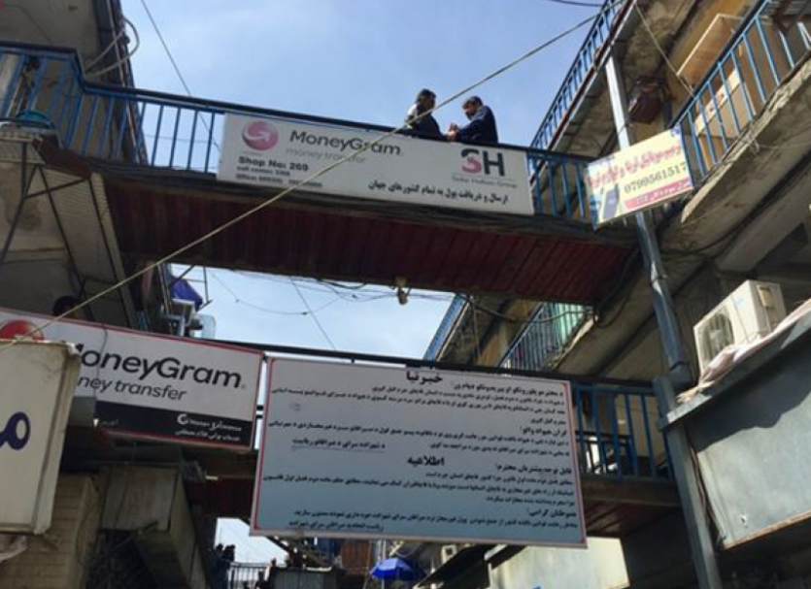

A billboard in Kabul, Afghanistan discouraging the use of the hawala system10.

### Binance

Binance has a tiered system for KYC requirements, allowing increased exchange limits the further up clients go in verification16a, 16b, 16c, 16d, 16e, 16f. All information is gleaned from Binance.US’s website, with with some missing information due to hardware limitations. The next best available information is for the United States. KYC requirements take up to 13 days to process.

|  |  |
| --- | --- |
| Transfer Range | Verification Tier | KYC Requirement |
| **Verified**  Fiat deposit & withdrawal limit: $50k daily  Crypto deposit limit: unlimited  Crypto withdrawal limit: 0.06 BTC daily16g  P2P transaction limit: unlimited  Other features: LPD/OTC/Binance card | Personal Information  Photo ID  Facial Recognition |
| **Verified Plus**  Fiat deposit & withdrawal limit: $200k daily  Crypto deposit limit: unlimited  Crypto withdrawal limit: 100 BTC daily  P2P transaction limit: unlimited  Other features: LPD/OTC/Binance card | Personal Information  Photo ID  Facial Recognition  Periodic Updates  Address Verification |
| **Enterprise Verification**  “Increase withdrawal limit to 100BTC”  “Increase deposit limits for some Fiat channels” | Company Information  Verify directors  Verify UBOs  Verify dealers/traders |

The required visible details of identification are as follows:

* Photo ID
  + ID type
  + ID number
  + Regulatory agency issuing ID
  + Expiration date
* Address verification
  + Documentary proof of residence
    - Utility bill
    - Account statement from different bank/credit card issuer
    - Lease agreement

Valid forms of identification are

* Government issued photo ID
* Driver’s license
* Passport
* PAN card
* Voter ID card

### OkCoin

OkCoin separates their levels of verification via two account types: individual and corporate. Within the individual accounts, there is also a tier system, known as “levels”17a, 17b. OkCoin also has clear documentation on the separate levels by country. The following table lists the limits for Afghanistan.

|  |  |
| --- | --- |
| Individual Accounts | |
| Transfer Range | Verification Tier | KYC Requirement |
| **Level 1**  Local currency deposit: $2,500 overall  Crypto deposit: $2,500 overall  Local currency withdrawal: $2,500 overall  Crypto withdrawal: $2,500 overall  Trading Unlimited: Unlimited | Personal information |
| **Level 2**  Local currency deposit: $1,000,000 daily  Crypto deposit: $1,000,000 daily  Local currency withdrawal: $1,000,000 daily  Crypto withdrawal: $1,000,000 daily  Trading Unlimited: Unlimited | Personal information  Photo ID |

|  |  |
| --- | --- |
| Institutional Accounts | |
| Transfer Range | Verification Tier | KYC Requirement |
| **Level 1**  N/A | Company information |
| **Level 2**  Local currency deposit: Unlimited  Crypto deposit: Unlimited  Local currency withdrawal: Unlimited  Crypto withdrawal: Unlimited  Trading Unlimited: Unlimited | Company information  “Additional company verification” |

The required visible details of identification are as follows:

* Personal Information:
  + Nationality
  + Full legal name
  + Date of birth
  + Country and state of residence
* Photo ID
* Picture
* Full legal name
* ID number
* Expiration date

### CoinMama

CoinMama follows suit with a tiered system for their account verifications. Their spending limits are “rolling limitations”, meaning they reset exactly 30 days after the first transaction rather than the first of every month. CoinMama has a maximum order quantity imposed18a, 18b, 18c, 18d, 18e.

|  |  |
| --- | --- |
| Transfer Range | Verification Tier | KYC Requirement |
| **Level 1**  Bankcard limit (buy): 15,000 USD  Wire transfer (buy, sell): 15,000 USD | Personal information  Photo ID  Image of a sheet of paper containing the phrase: “CoinMama” and today’s date |
| **Level 2**  Bankcard limit (buy): 50,000 USD  Wire transfer (buy, sell): 50,000 USD | Personal information  Photo ID (x2)  Utility bill  Complete KYC questionnaire18f  Spend 2,400 USD on account  Image of a sheet of paper containing the phrase: “CoinMama” and today’s date |
| **Level 3**  Bankcard limit (buy): 1,000,000 USD  Wire transfer (buy, sell): 1,000,000 USD | Personal information  Photo ID (x2)  Utility bill  Complete KYC questionnaire18f (x2)  Spend 50,000 USD on account  Image of a sheet of paper containing the phrase: “CoinMama” and today’s date |
| **Level 4 (Likely enterprise account)**  “Tailored to needs” | “Depending on type of organization” |

The required visible details of identification are as follows:

* Personal Information:
  + Full legal name
  + Date of birth
* Photo ID
* Picture
* Full legal name
* ID number
* Expiration date

Valid forms of identification are:

* Photo ID
  + Government issued photo ID
  + Driver’s license
  + Passport

### Comparison

Compared to the pure crypto-remittance providers, the traditional remittance providers have a much less documented KYC process. Additionally, the KYC process for traditional providers are much less stringent, either requiring no or a “only-photo” identification, leading to a near instant processing time. Crypto is often advertised as an alternative currency that has a heavy emphasis on security and accessibility, and this is heavily reflected in the additional security measures and documentation of their KYC process.

Between the crypto-remittances, CoinMama has the most stringent KYC conditions, despite being the newest provider. CoinMama also posts a monthly (30-day period) limit in addition to a daily limit, unlike the other two which only have daily limits. CoinMama does not differentiate between fiat and crypto exchanges, while the other two do. Binance seemingly has the highest amount of crypto exchange allowable for the fewest sources of identification, as well as, the highest absolute amount for its daily exchange at close to five million USD.

|  |  |  |  |
| --- | --- | --- | --- |
| Crypto-Remittances Comparisons Summarized | | | |
|  | Binance | OkCoin | CoinMama |
| Number of account tiers | 3 | 3 | 4 |
| Number of unique KYC requirements | 3-7 | 1-3 | 3-9 |
| Total crypto withdraw (lowest verification) | 0.06 BTC  ~$2900 | $2,500 | $15,000 |
| Total crypto withdraw (highest verification, non-enterprise account) | 100 BTC  ~$4,800,000 | $1,000,000 | $1,000,000 |
| Total crypto withdraw (enterprise account) | Unlimited | Unlimited | Unlimited |

## Conclusion

Overall, the KYC requirements of crypto-remittance providers are quite similar in the level of verification required for their lowest level (the “basic account”). They do, however, diverge at the highest levels of verification, with CoinMama requiring a total of 9 sources compared to OkCoin’s requiring three. All three crypto-providers offer an enterprise-level account that unlocks the limit on exchanges, but requires specific contact and custom verification.

# Report Considerations

## Report Shortcomings

### Project Statement Difficulties

**Difficult to determine criteria for “top” remittance provider.** Without any kind of direct user data, it is difficult to gauge which remittance providers are dominant in Afghanistan. As a result, this report used publicly accessible data to estimate the size of each provider globally, which is assumed to correlate with popularity in Afghanistan.

### Data Deficiencies and Researcher Bias

**Sample size is quite small.** While this report is an honest start, it is still too small (only five providers) to draw any major conclusions on KYC requirements. The small sample size introduces overemphasis and data bias.

**“Top” providers are exclusively from countries outside Afghanistan (UK, USA).** Many of the country’s current regulated remittance providers are Western providers. While research showed that the Afghan government had ongoing initiatives to increase regulated money transfers, this report was unable to locate examples. This relatively homogenous group of providers could potentially bias the data, as it is more telling of Western remittance providers rather than local, formal Afghan remittance providers.

**Data exclusively from online resources.** Data in this report is sourced exclusively from online articles, social reports, NGO webpages, government websites, provider apps/websites, news sources, and Wikipedia. A less biased literature review would include primary and secondary sources from Afghan companies directly, field reports, surveys, and even academic journals.

**Data was sourced in English, from a location on the US east coast.** Google leverages the user location in order to narrow down search results. As someone who conducted this research on the east coast in English, this “English-only” search filtering introduces selection bias. Data is not randomly drawn from the global pool of information on Afghanistan remittance providers.

**Data sourcing methods are unknown.** It is important to consider whether the data sources used in this report obtain their own sources with “due diligence”: ethically, accurately, comprehensively, and so forth. While the few academic studies cited here do provide documentation on their data sourcing, the bulk of the sources used in this report (government websites and news articles) do not *explicitly* elaborate on their sourcing. While there were no red flags during my research process, the lack of confirmation is still an issue and potential bias worth noting.

### Confounding Variables

**Non-financial factors have a massive impact on Afghanistan's financial systems.** While the hawala remittance system directly sandbags the development of federally and privately regulated currency transfer services, this report would be remiss if it did not also acknowledge the many social, political, and historical factors that influence Afghanistan’s economy. Swiftly following the US departure from Bagram Airbase back in July – officially ending the War in Afghanistan (2001-2021) – Taliban forces quickly seized the country. Internationally unrecognized, the new Talbian administration is left alone to restart an economy that has shrunk 40% since American withdrawal19. An article from JustSecurtiy.org20 suggests that there are providers and government entities that are intentionally restricting their operations as a means of “counter-terrorist financing”. These are all examples of major non-financial factors that influence the data surrounding the development of crypto-remittance providers and their KYC requirements.

## 

## Possible Future Research

While researching this report led to some answers, it also generated some more questions. Here are a number of tangent research topics that might better inform this report and/or would make for an interesting meta-analysis.

* How do Afghanistan’s requirements compare to those of other countries in the “Middle East and North Africa” meta-region (as defined by World Bank)?
* How does Afghanistan’s KYC requirements compare to the USA’s?
* Are there any strongly correlated economic (or otherwise) metrics with remittance percentage: CPI, poverty, GDP, employment rate, bank account ownership rate, exports, inflation rate, etc?
* Why does El Salvador have such a high percentage of remittances to GDP? (See Research Process: Visualization.)

# Supplementary

## Research Process

This section outlines the problem-solving approach used for this report. The process starts with a brief landscape survey of the topic before engaging in focused research, which helps with project and data contextualization. Relevant figures are included in the following section.

1. **Understand project statement**
   1. What are remittances?1
   2. What are KYC requirements?2
2. **Establish background knowledge of remittances**
   1. What is the loose history of remittances?3
   2. What is generally happening with remittances right now?4
   3. What are remittance requirements like in the US?5, 6
   4. What “major” news is going in the region?7
3. **Determine best project statement option**
   1. Where are these countries represented geographically?Fig S1
   2. Are there any regional categories that these countries belong to?Fig S2, 9
   3. What are some general characteristics of each country?Fig S3
   4. How do these characteristics compare to each other?Fig S4
4. **Research project statement on Afghanistan**
   1. What is the relevant background information for understanding crypto-remittances in Afghanistan?
   2. How do you determine “top” providers?
   3. What are the top crypto-remittance providers?
   4. What are their KYC requirements?
   5. How do they compare with each other?
5. **Reflect on research**
   1. What are the shortcomings (biases, data lapses, time frame) in this report?
   2. What other future research topics could inform this report more?

## 

## Research Process: Visualizations

Plotting each country on the world map helps reveal any immediate geolocational patterns.

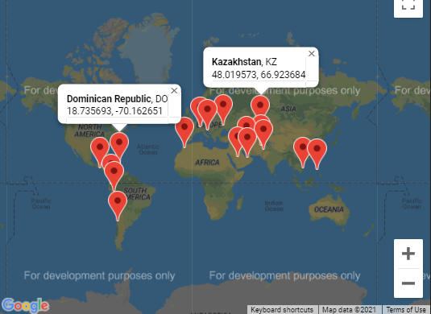

Fig S1: Python-GMaps-created world map of each country’s geocoordinates.

A geographic contextualization also helps with identifying any potential clustering within the country data, which might be useful for intra-continental comparisons and trend discovery. The countries are organized into the regional categories defined by the World Bank6.

|  |  |  |  |
| --- | --- | --- | --- |
| Latin America & Caribbean | Europe & Central Asia | Middle East & North Africa | East Asia & Pacific |
| Chile  Dominican Republic  El Salvador  Ecuador  Peru | Croatia  Kazakhstan  Switzerland  Ukraine | Afghanistan  Iran  Morocco  Pakistan  Saudi Arabia  United Arab Emirates | Philippines  Vietnam |

Fig S2: Table dividing countries into four meta-regions.

To characterize each country even further, the WorldBank API was utilized to pull data on each country’s poverty headcount percentage, personal remittance percentage (% of GDP), consumer price index, and gross domestic product. The results are pulled into a Python-Pandas dataframe shown below and then exported into a .csv.

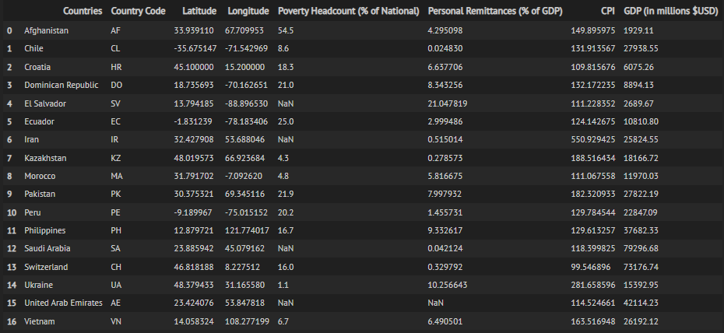

Fig S3: Pandas dataframe that shows pulled data.

These results were then graphed to visually compare the countries. Please refer to the prework_graph.png for a more detailed view; Google Docs automatically down-sizes images so that they fit to the page.

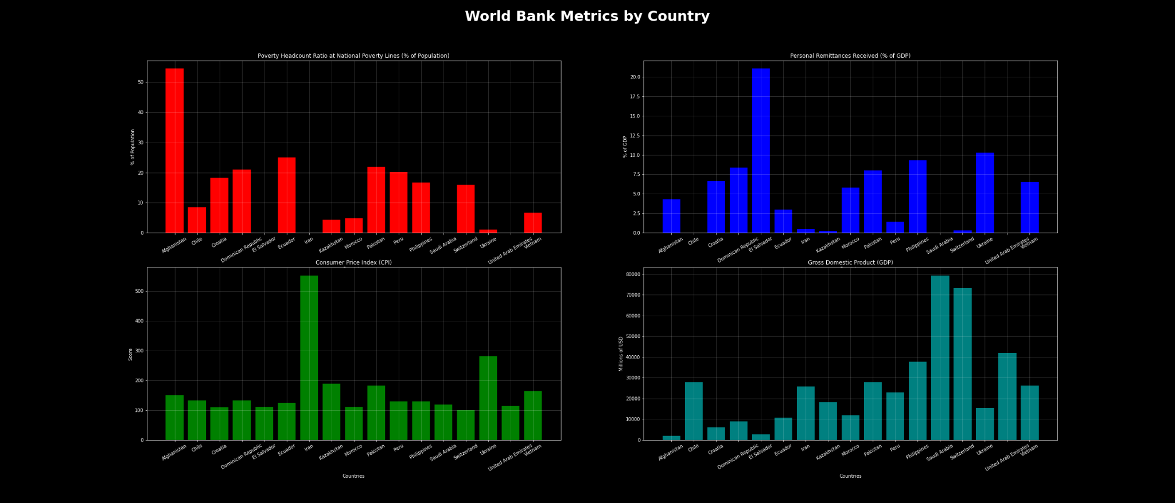

Fig S4: Bar charts that graph the pulled data.

**Red**: poverty percentage | **Blue**: remittance percentage of GDP

**Green**: consumer price index | **Teal**: gross domestic product

From the graphs, there are two potential countries that are the most interesting for further investigation: Afghanistan with the highest poverty percentage (56% to national) and El Salvador with the highest percentage of remittances to GDP (22.5%). Having learned that remittances are the main economic lifeline to the poor, I decided on investigating Afghanistan further, though supplementary research into El Salvador would be interesting as well.

The graphs on CPI and GDP helped compare two general economic indicators between each country, though these were mainly for my own curiosity. If I were pursuing an international comparison, the CPI and GDP would be useful anchors for scatter plots visualization.

# Report Bibliography

1. <https://en.wikipedia.org/wiki/Remittance#History>
2. <https://www.worldbank.org/en/news/press-release/2021/11/17/remittance-flows-register-robust-7-3-percent-growth-in-2021>
3. <https://techcrunch.com/2021/10/09/crypto-remittances-are-a-lifeline-for-the-worlds-most-vulnerable/>
4. <https://globalfindex.worldbank.org/>
5. <https://2009-2017.state.gov/j/inl/rls/nrcrpt/2014/vol2/222474.htm>
6. <https://www.migrationdataportal.org/blog/remittances-afghanistan-lifelines>
7. <https://www.reuters.com/business/western-union-suspends-services-afghanistan-2021-08-19/>
8. <https://www.migrationdataportal.org/international-data?i=remit_re_excel&t=2013&cm49=4>
9. <https://www.samuelhall.org/publications/afi-financial-inclusion-of-forcibly-displaced-persons>
10. <https://static1.squarespace.com/static/5cfe2c8927234e0001688343/t/60892b13db454d424c5f62ad/1619602209073/AFI_FDPs_CS_AW_digital_0.pdf>
11. <https://www.cnbc.com/2021/08/18/new-cryptocurrency-bitcoin-user-global-map.html>
12. Retuers
    1. <https://www.reuters.com/business/western-union-suspends-services-afghanistan-2021-08-19/>
    2. <https://www.reuters.com/world/asia-pacific/exclusive-western-union-resuming-services-afghanistan-senior-exec-2021-09-02/>
13. <https://www.bitrawr.com/afghanistan>
14. Western Union
    1. <https://www.westernunion.com/at/en/identification.html>
    2. <https://www.westernunion.com/es/en/faq-identification.html>
    3. <https://www.westernunion.com/fr/en/faq-identification.html>
15. Moneygram
    1. <https://id.moneygram.com/>
    2. <https://corporate.moneygram.com/documents/corp%20site%20docs/compliance/us%20agents/binder_section_2.pdf>
    3. <https://cointelegraph.com/news/moneygram-ceo-the-more-we-know-about-you-the-easier-it-is-to-send-money>
16. Binance
    1. <https://www.binance.com/en/blog/ecosystem/%E2%80%8Bwhat-is-kyc-or-identity-verification-and-how-is-it-increasingly-important-for-crypto-421499824684902130>
    2. <https://www.binance.com/en/blog/ecosystem/binance-expands-global-kyc-requirements-to-further-user-protection-421499824684902585>
    3. <https://academy.binance.com/en/glossary/know-your-customer>
    4. <https://www.binance.com/en/blog/community/moving-crypto-forward-with-updated-kyc-policies-on-binance-421499824684902779>
    5. <https://www.binance.com/en/support/faq/360027287111>
    6. <https://www.binance.com/en/support/faq/360015552032>
    7. <https://cryptoslate.com/binance-limits-daily-withdrawals-to-2000-for-basic-accounts-amid-regulatory-woes/>
17. OkCoin
    1. <https://support.okcoin.com/hc/en-us/articles/360054195732-How-do-I-verify-my-identity-and-start-buying-on-Okcoin-com-from-the-US->
    2. <https://support.okcoin.com/hc/en-us/articles/360054661171-What-are-my-deposit-and-withdrawal-limits->
18. CoinMama
    1. <https://www.coinmama.com/blog/how-to-get-verified-for-a-coinmama-account-level-1/>
    2. <https://support.coinmama.com/hc/en-us/articles/360012679219-Level-1-verification>
    3. <https://support.coinmama.com/hc/en-us/articles/360012587500-Level-2-verification>
    4. <https://support.coinmama.com/hc/en-us/articles/360012587640-Level-3-verification>
    5. <https://support.coinmama.com/hc/en-us/articles/360012592360-Account-limits-buy-sell->
    6. <https://assets.coinmama.com/kyc/Private_Customer_KYC_Questionnaire_and_Service_Aplicant_Declaration_Form.pdf?_ga=2.133746120.716445191.1639570261-672578112.1639570261>
19. <https://www.wsj.com/articles/crisis-looms-for-taliban-afghanistan-and-rest-of-world-11639104243?cx_testId=3&cx_testVariant=cx_2&cx_artPos=0&mod=WTRN#cxrecs_s>
20. <https://www.justsecurity.org/78221/reassessing-counter-terrorism-financing-in-a-taliban-controlled-afghanistan/>

# Supplementary Bibliography

1. <https://www.imf.org/external/Pubs/FT/fandd/basics/76-remittances.htm>
2. <https://www.trulioo.com/blog/kyc>
3. <https://en.wikipedia.org/wiki/Remittance#History>
4. <https://www.worldbank.org/en/news/press-release/2021/11/17/remittance-flows-register-robust-7-3-percent-growth-in-2021>
5. <https://www.pymnts.com/news/cross-border-commerce/cross-border-payments/2021/new-data-25-percent-united-states-cross-border-remittance-senders-use-cryptocurrency/>
6. <https://www.pymnts.com/tag/kyc/>
7. <https://www.wsj.com/articles/u-s-banks-and-money-transfer-firms-tread-carefully-in-taliban-controlled-afghanistan-11629557127>
8. <https://www.worldbank.org/en/about/annual-report/region-perspectives>